**1st Waveform**

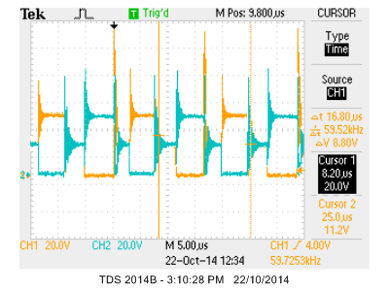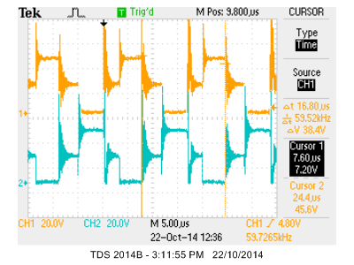

Vt1 – ch1

Vt2 – ch2

**Power Calculation**

Vin = 21.5V Iin = 1.47A

Vout = 8.77V Iout = 2.98

**2nd Waveform**

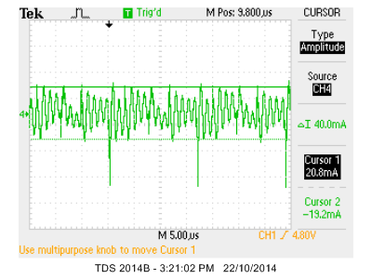

Iout at AC Coupling

**3rd Waveform**

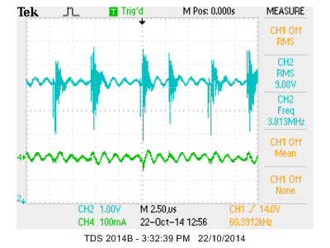

Vout at CH2 – note RMS value

Iout at CH4

**4th Waveform**

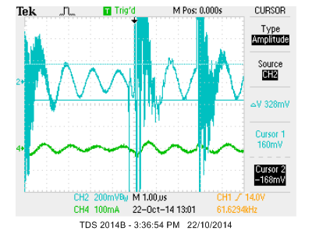

Vout at AC coupling on CH2 – note ripple voltage

**5th Waveform**

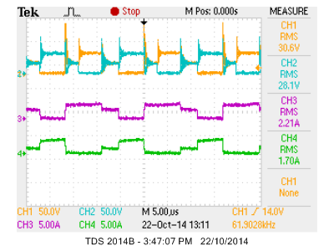

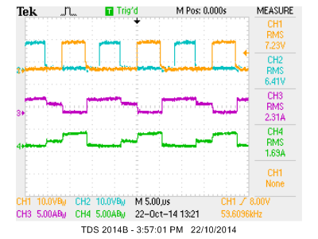

Vt1 and Vt2 on CH1 and CH2

Id2 and Id1 on CH3 and CH4 – note difference in waveforms, fast reacting diode?

**6th Waveform**

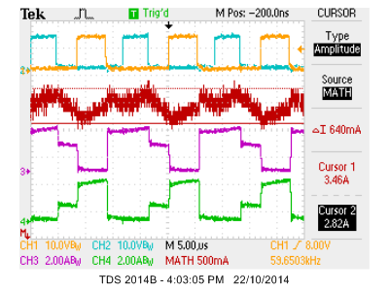

IL is calculated by (Id1 + Id2) with MATH (consider deletion)

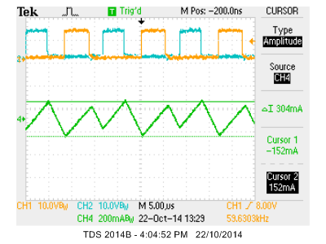

IL ripple measured using cursor. Note ripple value < 400mA

**7th Waveform**